Homework 03

STRUCTURAL DYNAMICS AEROELASTICITY

A. Vibration of a cantilever beam of length l, and section properties EI, GJ, m, I₀ 3
B. Aeroelastic equations of A straight wing of length l, and section properties EI, GJ, m, I₀, x_{CP}, x_{QP} 5
C. Ground vibration test (GVT) simulation for N_{w}=4, N_{ϕ}=3 6
D. Flutter eigenvalue analysis for N_{w}=4, Nϕ=3 7
E. Extra Credit Challenge Problems 8

Consider an aircraft wing undergoing testing at the ground and in flight with various airspeeds U (Figure 1). The wing is fixed at one root and free at the tip. The wing is of rectangular shape with straight elastic, mass, and aeroelastic axes. The elastic axis passes through P, the mass axis passes through C, and the aerodynamic axis passes through Q. The distance from P to C is the mass offset x_{CP}. The distance from P to Q is the aerodynamic offset x_{QP}. The wing undergoes oscillatory motion with plunge displacement w(z,t) and pitch displacement ϕ(z,t). The positive plunge direction is downward. The positive pitch direction is “nose up” (clockwise).
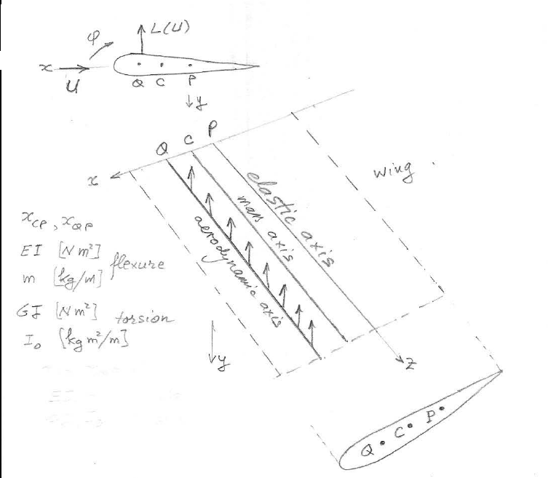
Figure 1: Aircraft wing testing

Given:
Air density: ρ=1.225 kg/m³
Chord: c=0.45 m
Mass, m=3.2 kg
Mass moment of inertia, I₀=0.055 kg.m²
Plunge frequency of equivalent rigid airfoil: f_{h}=1.8 Hz
Pitch frequency of equivalent rigid airfoil: f_{θ}=5.3 Hz
Static offset: x_{CP}= –10% of c
Aerodynamic offset; x_{QP}=35% of c
Wingspan: l=2.5 m

NOTES:
- For all numerical work, display the input data and then display your results
- Show work and relevant comments
- Always display input data!
- Partial credit might be given based on work done and MATLAB codes if they are attached; without them, no partial credit can be given.
- Display numerical results to three significant digits (four if the first digit is 1).
- Problems solved beyond the minimum requirements will be given bonus points.
- Challenge problems are optional. They may be solved for extra credit

Display input data

Vibration of a cantilever beam
of length l, and section properties EI, GJ, m, I₀

Flexural vibration
- Recall the formulae for flexural frequencies and modeshapes of a fixed-free beam
- Calculate and display the roots γl of the characteristic equation for N_{w}=4
- Calculate and display the flexural stiffness EI such that the fundamental flexural frequency matches the plunge frequency of the rigid wing section and display the resulting EI value and units
- Calculate and display the wavenumbers, natural frequencies in rad/s and Hz
- Calculate and plot the modeshapes

Torsional vibration
- Recall the formulae for torsional frequencies and modeshapes of a fixed-free beam
- Calculate and display the roots γl of the characteristic equation for N_{ϕ}=3
- Calculate and display the torsional stiffness GJ such that the fundamental torsional frequency matches the pitch frequency of the rigid wing section and display the resulting GJ value and units
- Calculate and display the wavenumbers, natural frequencies in rad/s and Hz
- Calculate and plot the modeshapes

Aeroelastic equations of A straight wing
of length l, and section properties EI, GJ, m, I₀, x_{CP}, x_{QP}
- Draw the free body diagram of an infinitesimal element of span dz
- Write the plunge and pitch equations of motion as a set of two partial differential equations (PDE) in space z and time t
- Eliminate the time dependency by assuming solution proportional to e^{st} and cast the equations of motion as a set of two ordinary differential equations (ODE) in space z
- Apply normal mode expansion with N_{w} flexural modes and N_{ϕ} torsional modes and recast the equations of motion as an algebraic matrix eigenvalue problem of dimension N=N_{w}+N_{ϕ} that depends on airspeed U

Ground vibration test (GVT) simulation for N_{w}=4, N_{ϕ}=3
Assume U=0
- Display the number of modes N_{w}, N_{ϕ} of the uncoupled problems and calculate and display the total number of modes N of the coupled problem
- Calculate and display the coupled flexural and torsional frequencies and eigenvectors. Discuss your results
- Calculate and plot the coupled modeshapes and discuss your results

Flutter eigenvalue analysis for N_{w}=4, Nϕ=3
- Let airspeed U=0,…,12 m/s with 1001 steps. Plot frequencies and damping vs airspeed and find the flutter speed U_{F} on the plots. Recall from HW01 the rigid airfoil flutter speed U_{F rigid} and discuss the results comparatively
- Calculate frequencies, damping, and eigenvectors around flutter speed, i.e., at U= (1–ε)U_{F}, U_{F}, (1+ε)U_{F}, ε=1% and discuss your results
- Plot flutter modeshapes at U_{F} and discuss your results

Extra Credit Challenge Problems
Challenge problems are optional

Flexural vibration analysis
Derive the equations of flexural vibration for frequencies and modeshapes

Answer

Students should write their own derivation using the class notes as a guide

Torsional vibration analysis
Derive the equations of torsional vibration for frequencies and modeshapes

Answer

Students should write their own derivation using the class notes as a guide

